**Opioid Crisis in Indiana**

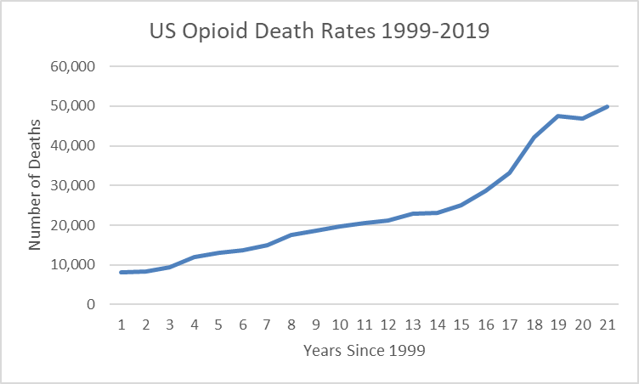

**Team name: Hack N’ Slash**

| **Name (full name)** | **Purdue Email address** |
| --- | --- |
| Sarah Dunn | dunn102@purdue.edu |
| Harshini Thambiah | hthambia@purdue.edu |
| Joy Gao | gao629@purdue.edu |
| Jeremy Chen | chen3191@purdue.edu |

Table of Contents

Introduction 3

Background 3

Questions 3

Problem Statement 3

Methodology 3

Results 3

Discussion and Conclusion 3

References 3

Appendix A – Resources Used 4

Datasets 4

Tools used 4

Appendix B – Percent Contribution 5

Group Contributions 5

Individual Contributions 5

Appendix C – Individual Contributions 6

Team Member #1: Harshini Thambiah 7

Team Member #2: Joy Gao 8

Team Member #3: Jeremy Chen 9

Team Member #4: Sarah Dunn 10

Appendix D - Diversity Statement 12

Appendix E – Team Consensus 13

Team Consensus 13

Opioid Crisis in Indiana

# Introduction

Opioid misuse has continued to be a serious public health crisis in Indiana. Overdose rates have increased dramatically since the late 1990s due to the widespread prescribing of pain relievers. The highly addictive qualities of pain relievers were heavily undermined by prescribers, leading to high overdose rates and consequently, high death rates. Geographic location; namely urban areas, and mental health are also contributing factors to increased opioid use. As a result, our team chose to argue a need for increased access to effective treatment programs and increased awareness over medication for anti-overdose and alternative pain relief methods.

# Background

Our team chose to research the opioid crisis in Indiana and how different factors such as geographic location, prescription rates and mental health play a role. We chose this topic because the opioid crisis is such a common problem in Indiana and we all wanted to learn more about it. As we were doing our own research, we learned that the rates of people dying from opioid abuse are rising and wanted to figure out what factors could explain *why* we are seeing these higher death rates.

We chose to use data provided by the Indiana drug data dashboard on the Next Level Recovery webpage and data gathered by the CDC. We focused on the data over the amount of deaths due to opioids by year, opioid prescriptions by year, and county response. We chose opioid deaths per year because this was helpful in letting us know how serious the problem was and whether there was an increasing trend or not. The opioid prescriptions dataset was helpful in telling us whether it contributed to increasing opioid rates. The county response dataset was necessary to tell if there was effective treatment for this problem.

# Questions

We chose to address two main questions through our research. One of these questions was: what are the factors contributing to high opioid death rates in Indiana? Since we discovered the extent of opioid abuse in Indiana, we wanted to delve deeper into the factors behind this problem. This leads into our next question: what are some solutions that can decrease death rates due to opioids in Indiana? We want to understand how to help decrease the problem of high opioid death rates.

Our intended audience are police officers, health officials, government officials, and social workers. These groups of people have the ability to pass policies that enact change. We want to address the ongoing problem with opioid abuse and the steps necessary to help alleviate this problem.

Treatment programs are available in some counties in Indiana. There are also some mental health programs to help combat opioid abuse for mental health patients. Drugs are also turned into the police if they are being used illegally. However, there has currently not been much research over the need for improved treatment programs in Indiana specifically. According to the National Institute of Drug Abuse, a lot of treatment programs don’t even use buprenorphine, which is regarded as highly effective for helping opioid addiction. That is why we wanted to spread awareness about this.

# Problem Statement

Opioid death rates have been visualized with line charts and bar charts before. For line charts, it shows a time-lime of comparing overdose rates and deaths based on the large data set that is being analyzed. Other than that, bar charts are usually used to compare specific drug type, location, death rates, etc.. While these types of graphs effectively show the increasing problem of opioid misuse, we decided to use other types of graphs including a map chart to compare opioid use and prescriptions with location. We also decided to use visualizations of mental health to aid our argument of mental health increasing opioid use.

Many people are affected by opioid abuse, and they are commonly prescribed by doctors, making them harder to avoid and it gives easier access to them. With the death rates increasing because of mental health it is unacceptable for Indiana to leave the crisis alone. From a couple datasets, we found that Indiana’s death rate is above average compared to the entire United State. People should be more aware of others who are in pain and help to find a solution for Opioid overdose.

# Methodology

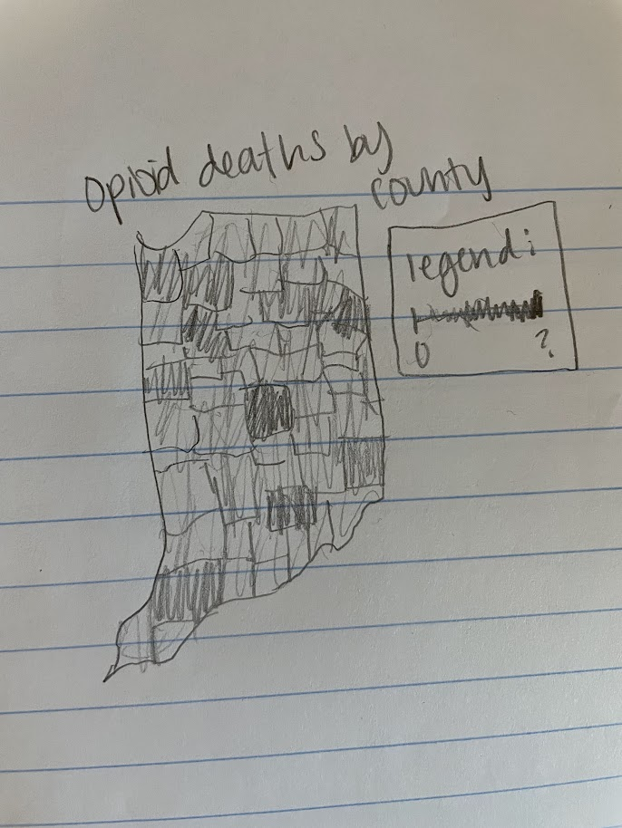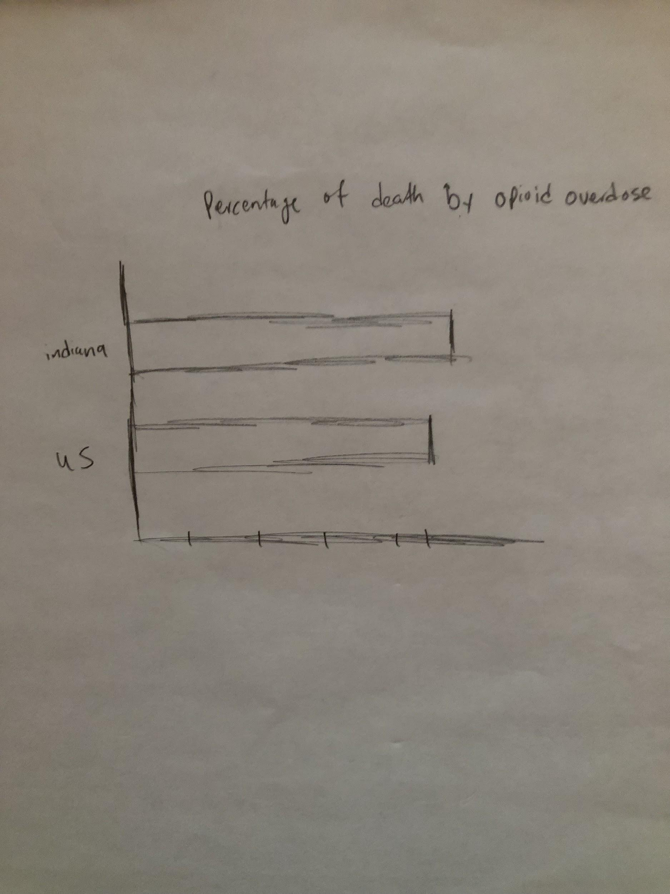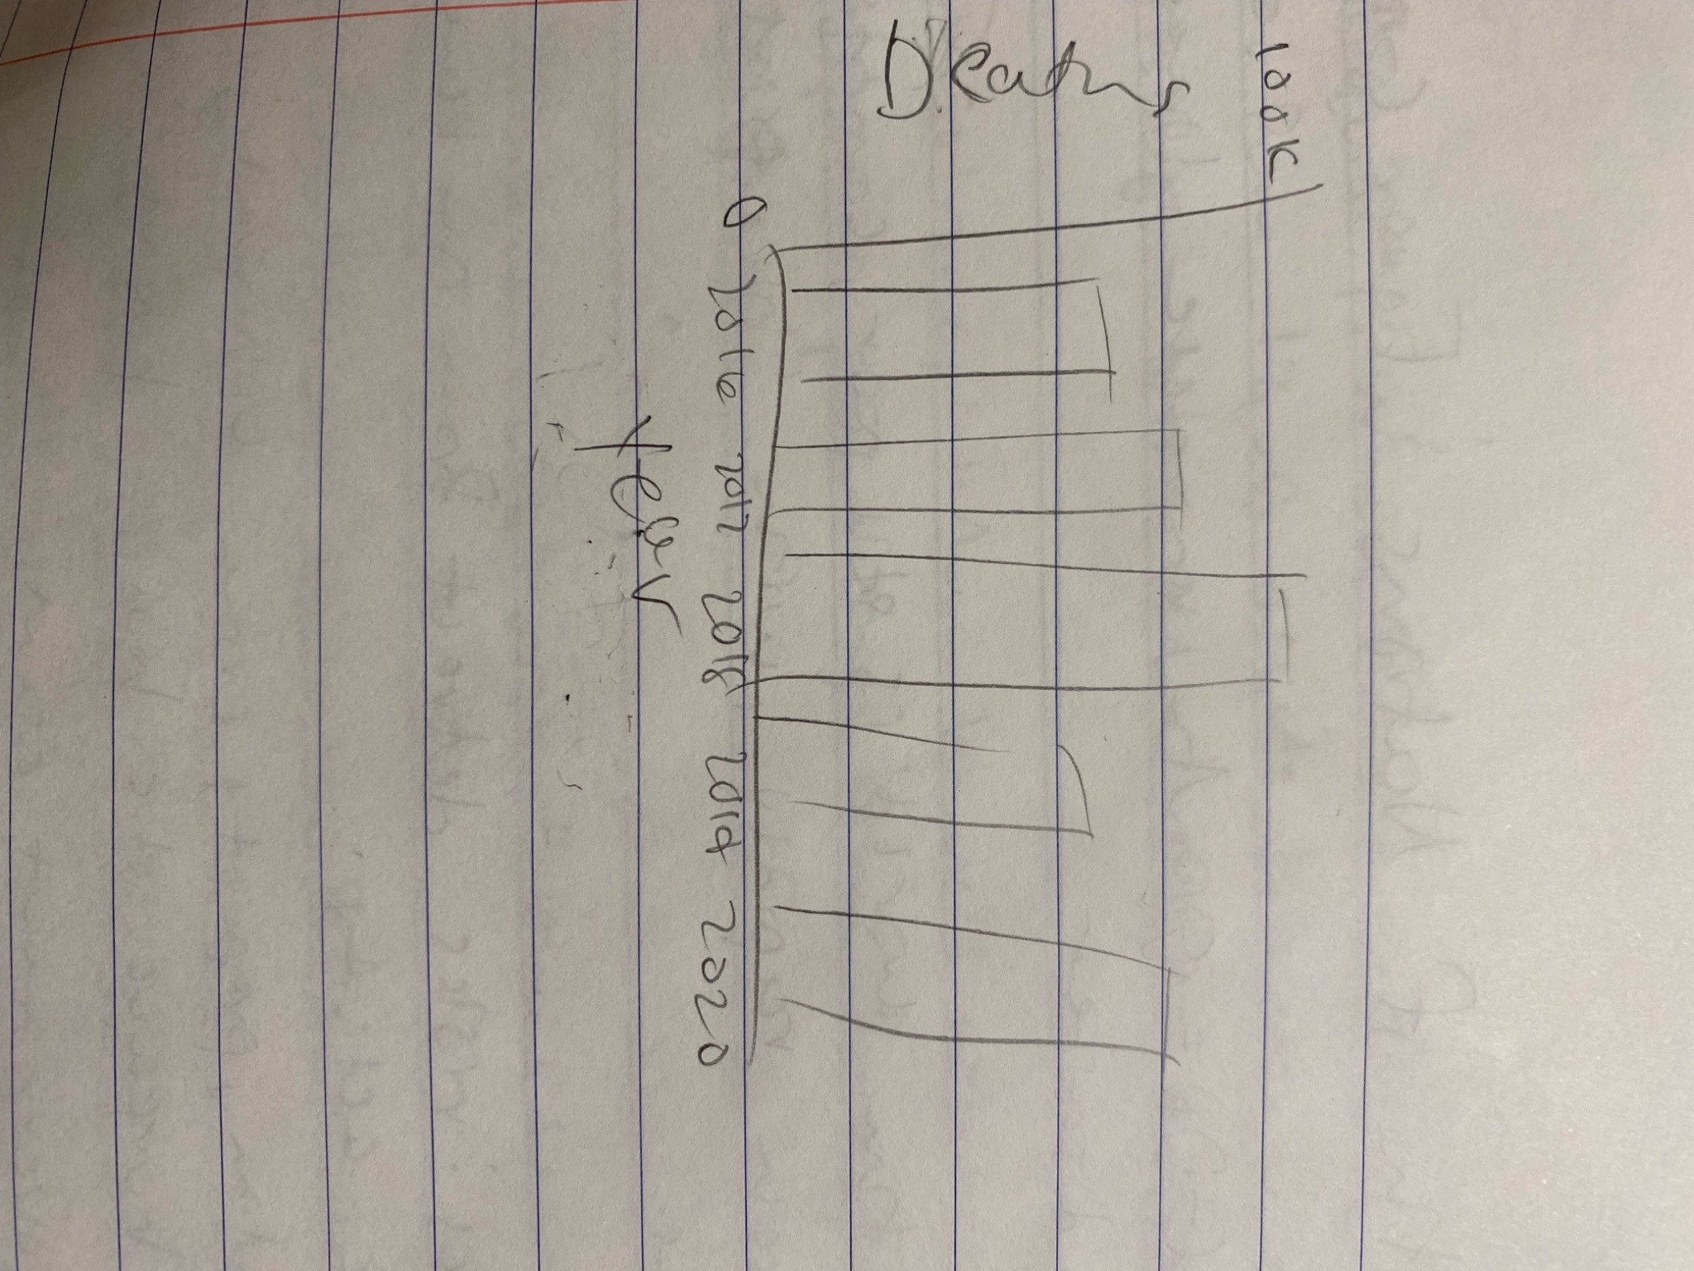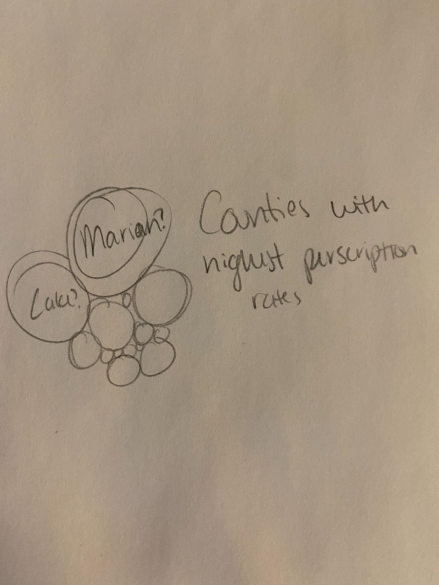

We acquired various data from either articles, government websites, studies, etc. and filtered through the data to find what we needed. We then visualized our data into geographic visualizations, heat maps, line graphs, and bar charts to help make it easier for people to see the information we are presenting.

# 

# Results

Joy Gao

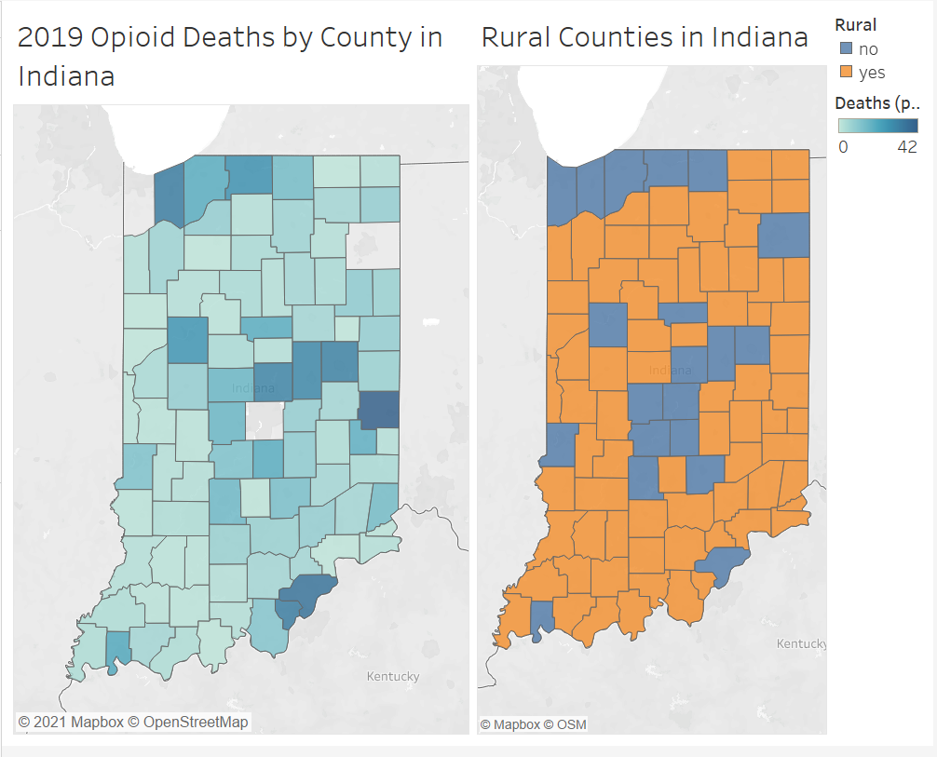

This visualization demonstrates the amount of deaths per 100,000 population for each county in Indiana. The counties range from light to dark blue depending on the death count. It excludes Lake, Allen, and Marion County because the death counts were so high in comparison to the rest of the counties, making it hard to tell the difference in shades of color. A visualization of rural and urban counties was also included to effectively compare death counts to rural or urban locations. Urban areas are represented by blue and rural areas are represented by orange.

Sarah Dunn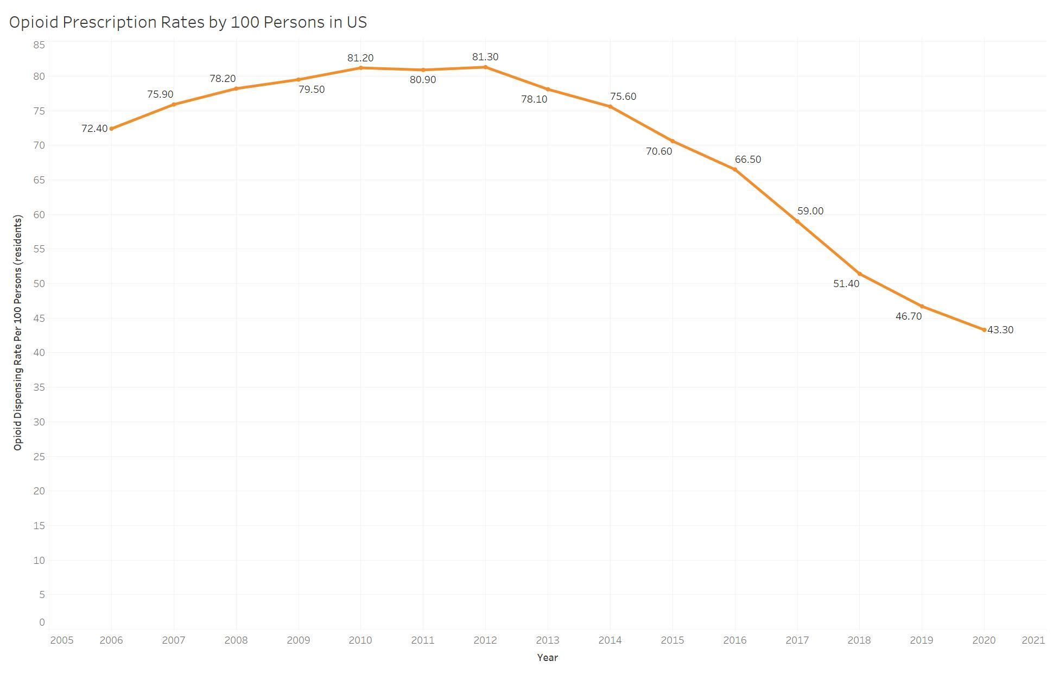

# 

# 

# 

# 

# 

# 

# 

One significant factor in the rise of opioid related deaths is the rate at which they are prescribed by doctors. We can assume that higher prescription rates can lead to more people using them and becoming addicted. In this visualization, we can see the average prescription rates in the United States each year, from 2006 to 2020, which are usually well over 50 prescriptions per 100 people, with a peak in 2012. The CDC notes that even though the prescription rates are lower in 2020, many individual counties still have a much higher prescription rate. 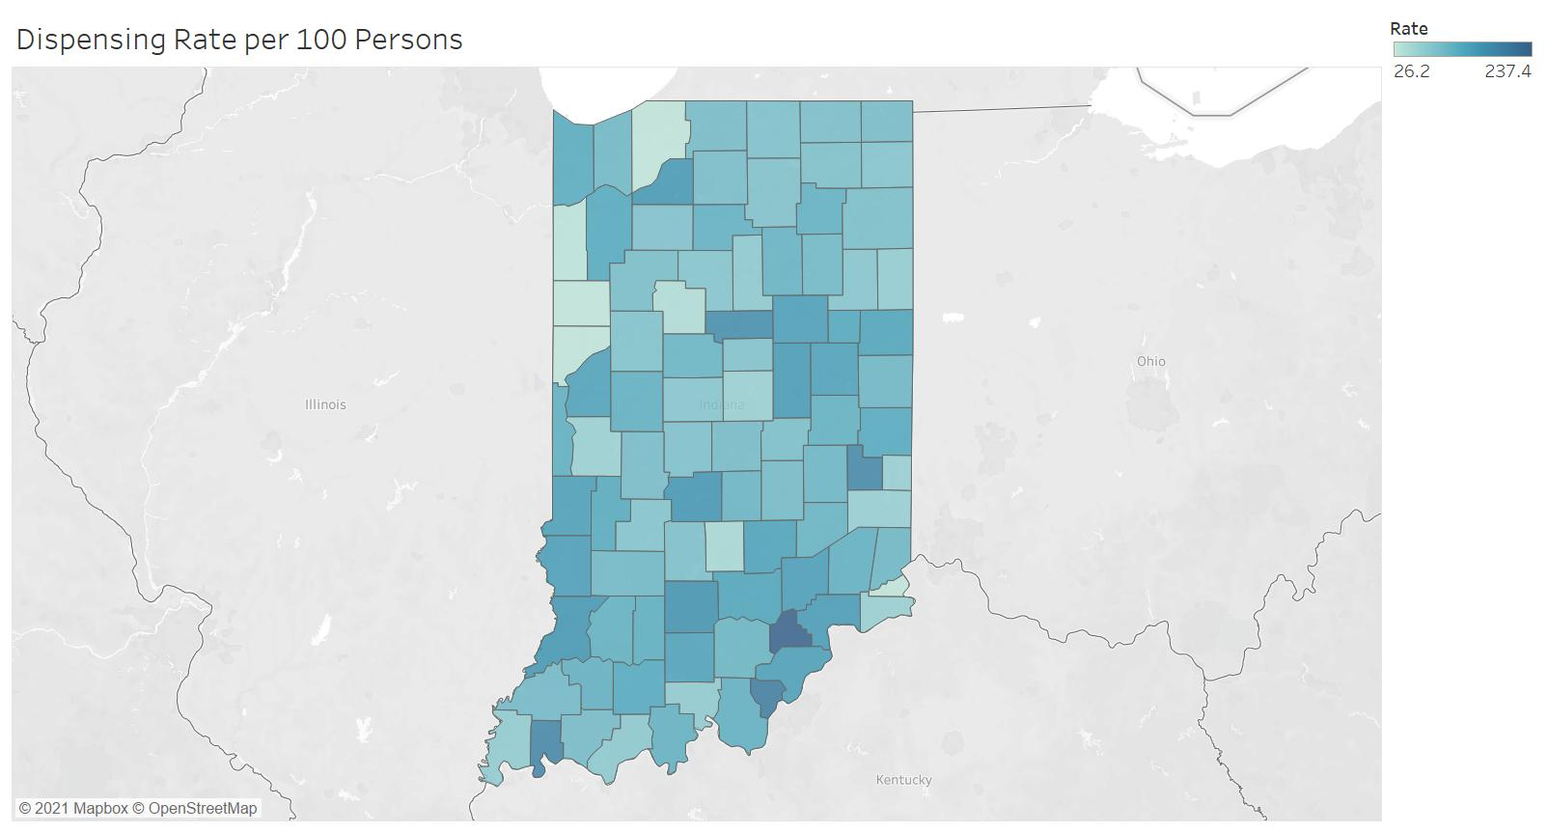

This next graph shows prescription rates in Indiana by county in 2012, which is the peak in the US. These rates range from 26 to 237 prescriptions per 100 people. As you can see, most counties are in the middle of that range, which is an average of 112 prescriptions per 100 people.

# Jeremy Chen

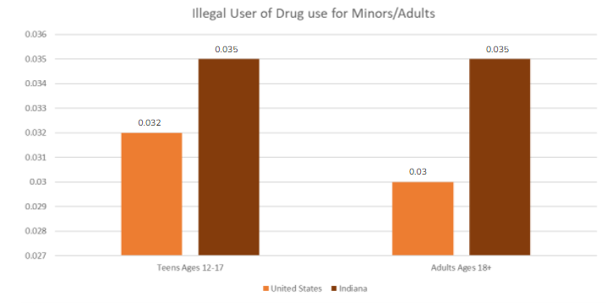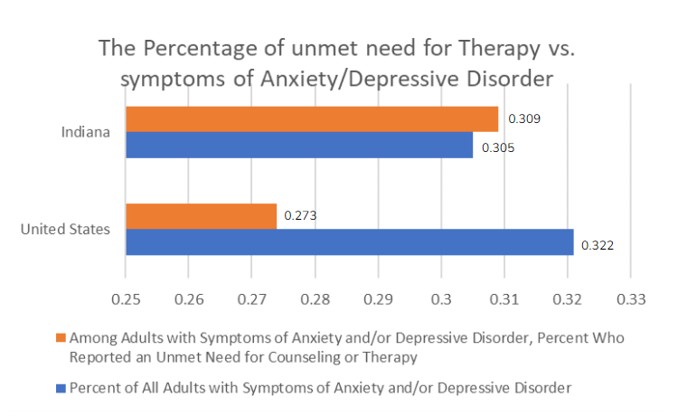

These visualizations show the comparison of teens and adults who use illegal drugs. From the visualization it is obvious that Indiana has a higher percentage in both teens and adults using drugs compared to the U.S.. To back up the visualization above I created another visualization on unmet need for therapy. This is a very important factor that contributes to people overdosing on drugs as well as consuming the drug from the beginning. Indiana has a higher percentage in untreated mental health conditions which resulted in people to go for self-medication.

Harshini Thambiah

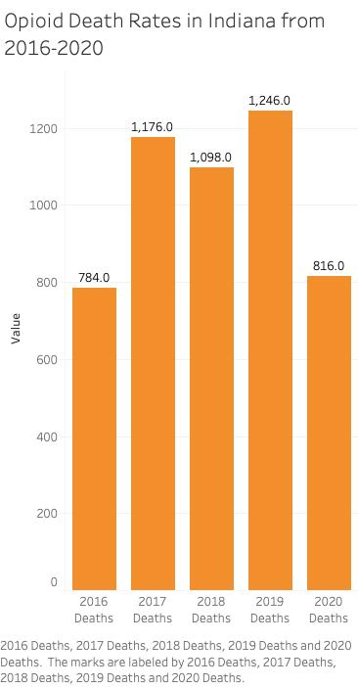

This visualization shows the total deaths per year in Indiana. The data counts all of the deaths in each county in Indiana and it gets the total. From the visualization it shows that 2016 had the lowest deaths than the later years but in 2019 the deaths have spiked. One assumption could be increased access to these drugs, either legal or illegal. After 2019, the amount of opioid deaths had fallen. This could be because of the pandemic as with social distancing and medical facilities being immensely busy combating the virus.

# 

# 

# Discussion and Conclusion

Our visualizations address the problem of rising opioid death rates by finding possible correlations between certain factors and opioid death rates. For example, our visualizations demonstrate that urban areas have higher death rates due to being more dense in population and having higher prescription rates. We also discovered through our visualizations that mental health issues increase the likelihood of opioid abuse. As a result, there needs to be more attention brought to improving treatment programs in these areas.

To help combat the rising number of deaths due to opioids, the state can create more accessible treatment programs to those suffering from opioid addiction. Especially in urban areas, steps can be made to make effective medication and/or therapy accessible to those who need it. We also learned that researching alternative pain medications could lower opioid prescription rates and therefore lower the death rates.

# References

<https://www.cdc.gov/drugoverdose/rxrate-maps/index.html>

<https://www.kff.org/statedata/mental-health-and-substance-use-state-fact-sheets/indiana/>

<https://www.drugabuse.gov/drug-topics/trends-statistics/overdose-death-rates>

<https://www.drugabuse.gov/publications/effective-treatments-opioid-addiction>

<https://www.in.gov/recovery/data/>

<https://www2.indstate.edu/news/pdf/2014-08_IN%20Rural_Counties_Economic_Overview.pdf>

Centers for Disease Control and Prevention. (2021, November 10). U.S. opioid dispensing rate maps. Centers for Disease Control and Prevention. Retrieved December 10, 2021, from https://www.cdc.gov/drugoverdose/rxrate-maps/index.html.

Mental health and substance use state fact sheets. KFF. (2021, May 26). Retrieved December 10, 2021, from https://www.kff.org/statedata/mental-health-and-substance-use-state-fact-sheets/indiana/.

National Institute on Drug Abuse. (2021, February 25). Overdose death rates. National Institute on Drug Abuse. Retrieved December 10, 2021, from https://www.drugabuse.gov/drug-topics/trends-statistics/overdose-death-rates.

National Institute on Drug Abuse. (2021, September 9). Effective treatments for opioid addiction. National Institute on Drug Abuse. Retrieved December 10, 2021, from https://www.drugabuse.gov/publications/effective-treatments-opioid-addiction.

NextLevel Recovery. (2021, November 10). Data. NextLevel Recovery. Retrieved December 10, 2021, from https://www.in.gov/recovery/data/.

Prior, C. (2014). Rural Indiana. Rural Indiana - A Demographic and Economic Overview. Rural-Urban Entrepreneurship Development Institute

# Appendix A – Resources Used

## Datasets

Indiana Drug Data Dashboard - County Response

Listed the treatment programs available in each county for opioid abuse in Indiana

Indiana Drug Data Dashboard - Deaths

Listed the number of deaths due to opioid overdose by 100,000 population per county in Indiana

Indiana Drug Data Dashboard - Opioid Prescriptions

Listed the amount of opioid prescriptions by prescribers per county in Indiana

CDC Opioid Dispensing rate

Listed in detail the dispensing rate for every county in the United States by year

## Tools used

List all tools used in the project and a brief description (see the examples below); add more if applicable.

| **Tool/Application** | **Description** |
| --- | --- |
| Excel | Data cleaning/Data visualization |
| Tableau | Data visualization |
| Weebly | Project website |

# Appendix B – Percent Contribution

## Group Contributions

Contributed to the data visualization process, brain stormed topic ideas and problem and solution, served as rotating team leader, contributed content to the short story (summary), contributed content to the 5-minute video and website, read the final deliverable before submission, created visualizations.

## Individual Contributions

In the table below list each team member’s full name, their contribution (body of work) and their % of the work completed. The total must add up to 100%

| **Team Member** | **Description** | **Contribution** |
| --- | --- | --- |
| Harshini Thambiah | Gathered datasets for the project, started and worked on the presentation, made a visualization, brainstormed topic ideas, came up with a problem for our group, served as rotating team leader | *25%* |
| Joy Gao | Found datasets, made visualizations, contributed to the report and presentation, came up with the solution, served as rotating team leader | *25%* |
| Sarah Dunn | Researched data for the project, created visualizations, created website, contributed to both the presentation and report, served as rotating team leader | *25%* |
| Jeremy Chen | Researched data for project, created visualizations, put together the video, contributed to both the presentation and report, served as rotating team leader | *25%* |
|  | Total | 100% |

# Appendix C – Individual Contributions

In this appendix each team member must contribute a one-page document relating the team’s topic/data to their hometown or home country. The one-page document must contain: (1) a description of the problem, (2) a comparison of the team’s findings with insights about your hometown/country related to the hackathon data (3) a visualization to support items (1) and (2).

Each person should create their individual page **(1-page only)** and make it available to the designated team member who will upload the final document.

This will be viewed and assessed as part of each person’s individual contribution.

Leave this page as is.

Start adding individual page content on the next page.

REMOVE any blank pages before submitting.

## Team Member #1: Harshini Thambiah

My Hometown/City/Country: Fishers, Indiana (Hamilton County)

Hackathon Topic (dataset): Opioid Overdose Death Rates in Indiana and Dispensing Rates in Indiana

Include your story and visualization below.

The opioid epidemic is slowly getting worse and worse each year. We discovered that since 1999, opioid deaths have steadily increased, in 2020, it had the highest recorded opioid deaths. According to the Official Indiana Website and highlighted in the bubble chart below, We found that there were a high number of death rates in urban areas like Marion county which had the most overdose deaths in 2020 than any other county having a total number of 214 deaths compared to Hamilton county which had 16 deaths (although it is also an urban area). Hamilton county has had a significant decrease in deaths since 2019 as the deaths for that year was 31. But where did they get the opioids? For some context on the opioids they are generally prescribed as pain killers, in the map of Indiana below these are the confirmed prescription dispensing rates per 100 people in each county, this information came from the CDC website and the year is in 2020. In the map below, Hamilton County’s dispensing rate is 41.5 while Indiana’s overall dispensing rate 56.9 per 100 people. I made the assumption that this means that most likely people are overdosing on drugs that they are prescribed to instead of overdosing on illegal drugs. I also assumed that since the dispensing rate in Hamilton county is small this means that the amount of deaths has decreased or is small as well and vice versa for Marion county. This also means that the dispensing rate in Hamilton county is less than the dispensing rate in Indiana as a whole, however Marion county’s dispensing rate is higher than Indiana and Hamilton county having the rate be 67.2 per 100 people.

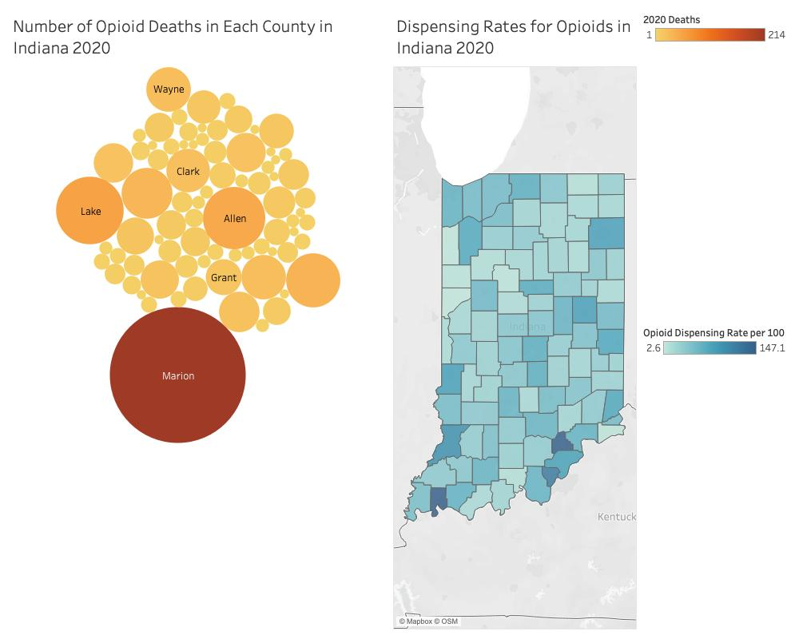

## Team Member #2: Joy Gao

My Hometown/City/Country: Carmel, Indiana (Hamilton County)

Hackathon Topic (dataset): Opioid Crisis in Indiana

Include your story and visualization below.

The opioid overdose crisis in the US has steadily grown over the years. According to the National Institute of Drug Abuse, in 2019, overdose deaths related to opioids climbed to nearly 50,000 compared to 21,000 deaths in 2010. Our team discovered similar increasing death rates in Indiana with 1,246 deaths in 2019 compared to 784 in 2016. We also discovered it is especially serious in urban counties in Indiana. According to our findings, urban counties have a higher death rate from opioid overdose than rural counties in the US from 2016 to 2019. I made the assumption that this is due to urban counties having increased access to prescription drugs. I also made the assumption that due to urban areas having increased population, there is a higher likelihood of opioid abuse occurring. My hometown, Carmel, which is located in Hamilton County, Indiana, is an urban area. The sum of deaths in 2019 for Hamilton (31), was fairly high compared to the average of rural counties in orange (5.4 deaths). This aligns with my findings of urban areas having higher death rates than rural areas. Hamilton County is also located right above Marion County which had the most opioid deaths. The proximity of my hometown to the city of Indianapolis may contribute to high opioid usage. I decided not to list out all the rural counties because there were too many and most had similar death counts so the average was a good indicator of how many deaths there were in rural counties.

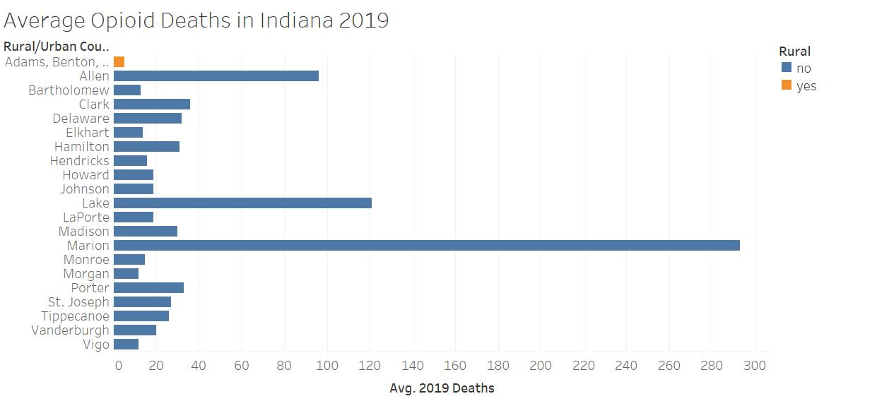

## 

## Team Member #3: Jeremy Chen

My Hometown/City/Country: Plymouth, Indiana (Marshall County)

Hackathon Topic (dataset): Opioid Crisis

Include your story and visualization below.

It is statistically proven that the Opioid epidemic has gotten worse every year. Based on the Kaiser Family Foundation, provided research on Indiana in 2019 about age adjusted death rate due to opioid overdose. The Indiana death rate was 26.6 per 100,000 compared to the US rate 21.6 per 100,000. We discovered that the death rate was in a steady increase each year until recent 2020. People stopped visiting to get prescriptions and this accelerated the death rate before it started to rise again. I have made an assumption that the overall death rate was still high and need to have more effective medical treatment. Places like Marshall county are not so populated so most of the cases are in bigger counties/cities. So I made a visualization that represents Indiana compared to the average of the US to show the importance of this crisis. People need to be more aware of the reason people use opioid to prevent it. Indiana also needs to make changes to the medical standard for mental health to lower the chances of people using opioids to relieve pain.

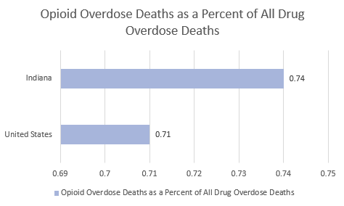

## Team Member #4: Sarah Dunn

My Hometown/City/Country: Indianapolis, Indiana

Hackathon Topic (dataset): Opioid Crisis

Include your story and visualization below.

Part of our research into the opioid crisis in Indiana included the growing death rates across the country. We learned that counties containing cities have significantly more deaths due than the more rural counties in the state. With my hometown being Indianapolis, Indiana, my county (Marion county) has the highest death rate in the state, about four times larger than the next highest county’s death rate. Part of the issue of the increasing death rate is how much opioids are being dispensed. Using data we gathered from the CDC, we can see that Indiana reached a peak in dispensing rates in 2012, with Marion county’s rate being about 101 prescriptions per 100 people. Even though those rates have dropped, they were still higher than the county's county average in 2020, with Marion county having about 67 prescriptions per 100 people, which is shown below as well. I can assume that the high population of Indianapolis plays a role in the high death rate. Since I am from Indianapolis, the opioid crisis is incredibly relevant since there are significantly high dispensing rates here, as well as the highest death rate in the state.

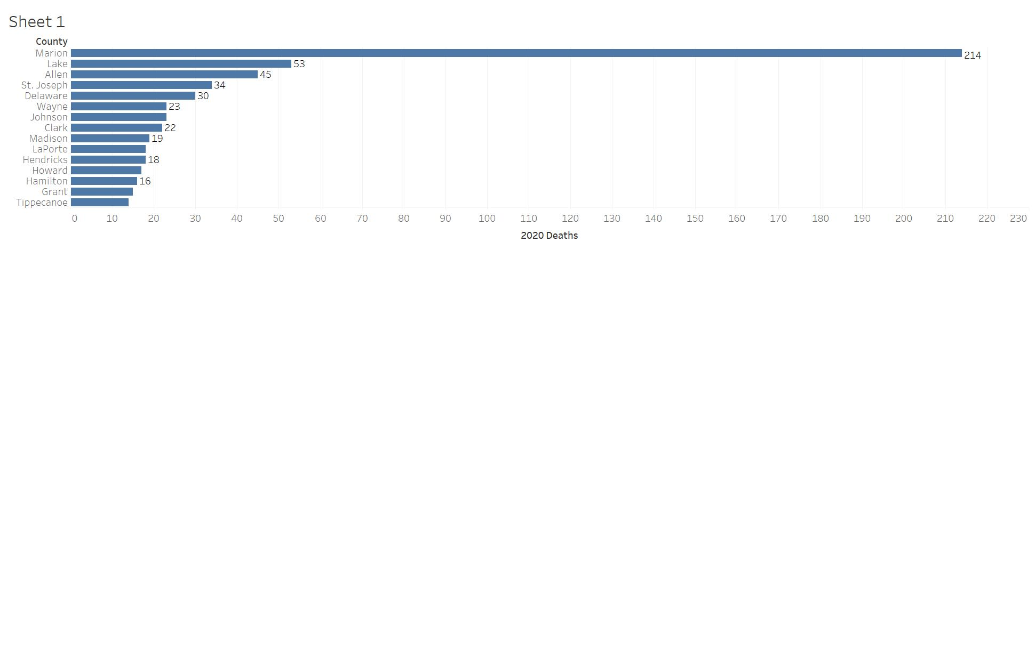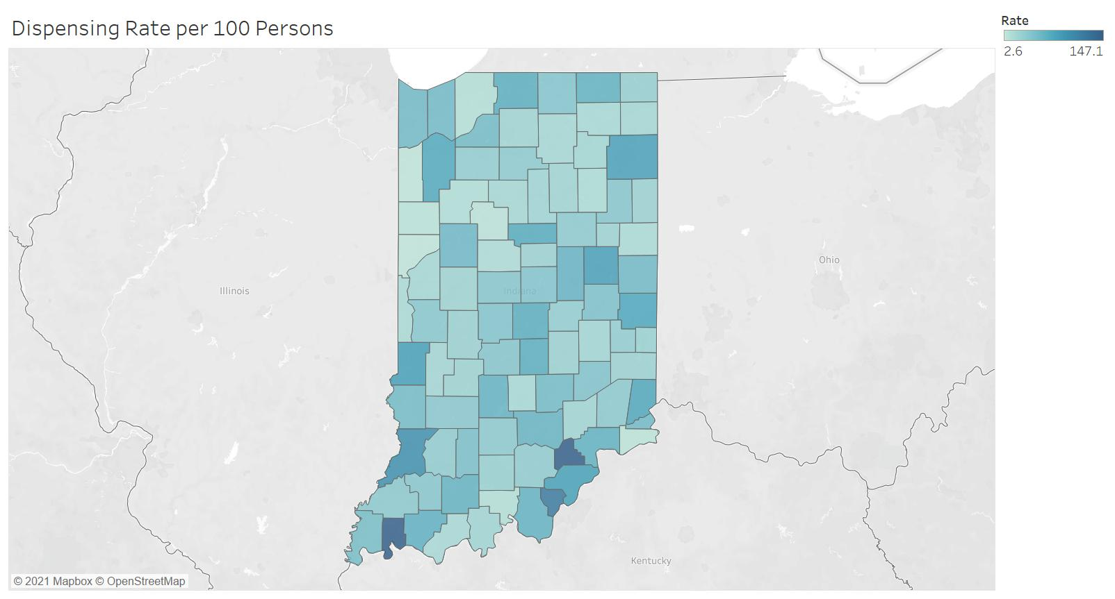

# Appendix D - Diversity Statement

Some of the most enlightening outcomes are generated by diverse teams working together to solve complex problems. What does diversity mean and why is it important? Merriam-Webster defines [diversity](https://www.merriam-webster.com/dictionary/diversity) as: 1) the quality or state of having many different forms, types, ideas, etc., 2) the state of having people who are different races or who have different cultures in a group or organization. When solving complex problems having adequate representation is important. In the context of the hackathon, diversity could mean (but is not limited to): varied perspectives, varied points of view, different academic majors represented, different academic levels (Freshmen, Sophomore, Junior, Seniors) on the team, different ethnicities (state this professionally). Having a diverse team from different backgrounds can boot engagement and productivity and make us smarter (read short article: “How diversity actually makes us smarter”).

In the space below, provide a statement describing the group’s diverse make up and how the diversity of the group contributed to the outcomes of the team’s deliverables for the hackathon. Every team member must contribute to the development of the diversity statement.

Team Hack N’ Slash is composed of members from different academic levels (freshman, sophomore, junior, and senior) and includes several different disciplines as well (Web Programming and Design, Data Visualization, and Psychology). Some members had little to no previous knowledge about the opioid crisis in Indiana while others had more. Although our team is all from Indiana, we come from different areas and may have different background knowledge about the opioid crisis. One member also had a personal experience with opioids where a family member was addicted to heroin.

Having diverse backgrounds and different perspectives as a group helped when it came to brainstorming ideas and finding solutions to problems. Each of us had different ideas when it came to possible factors in the rising death rate due to opioids, which gave us plenty of options to research further. Not only does diversity help working together as a team, but it makes the outcome better as well.

# Appendix E – Team Consensus

## Team Consensus

I have read and approved of the content as a representation of the team’s work and my contribution.

| Team Member (full name) | Signature | Date |
| --- | --- | --- |
| Sarah Dunn | Sarah Dunn | 12/09/2021 |
| Joy Gao | Joy Gao | 12/07/2021 |
| Harshini Thambiah | Harshini Thambiah | 12/03/2021 |
| Jeremy Chen | Jeremy Chen | 12/06/2021 |